Spring.xml

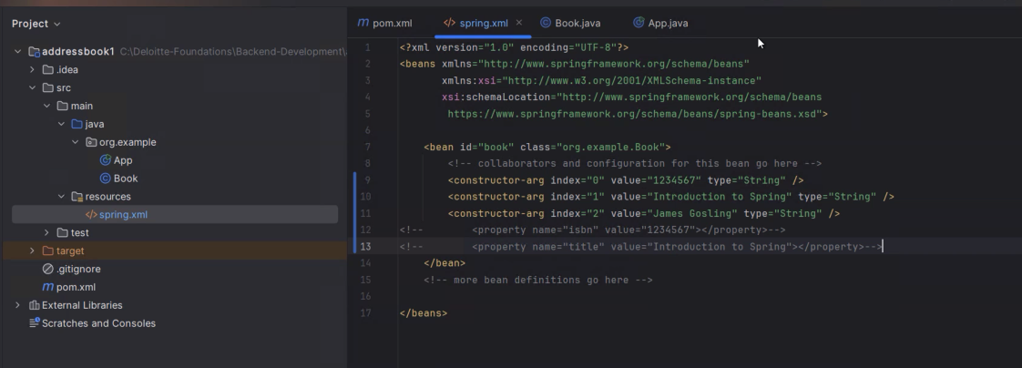

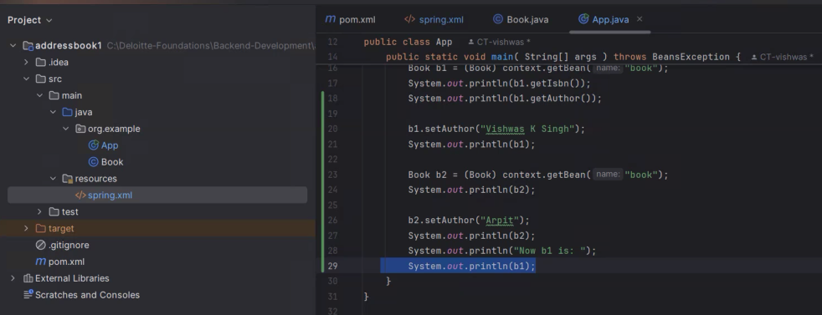

Spring.xml

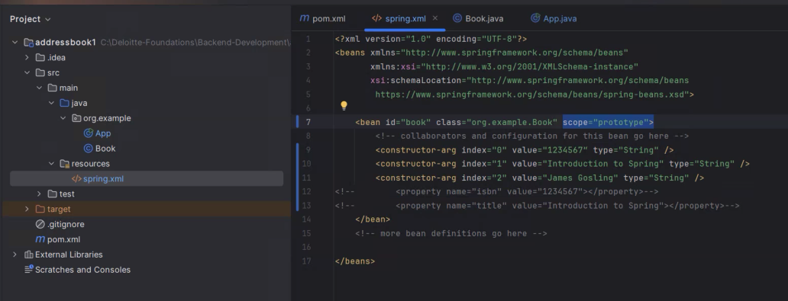

[GitHub - Deloitte-vishwas/Deloitte-Foundations](https://github.com/Deloitte-vishwas/Deloitte-Foundations)

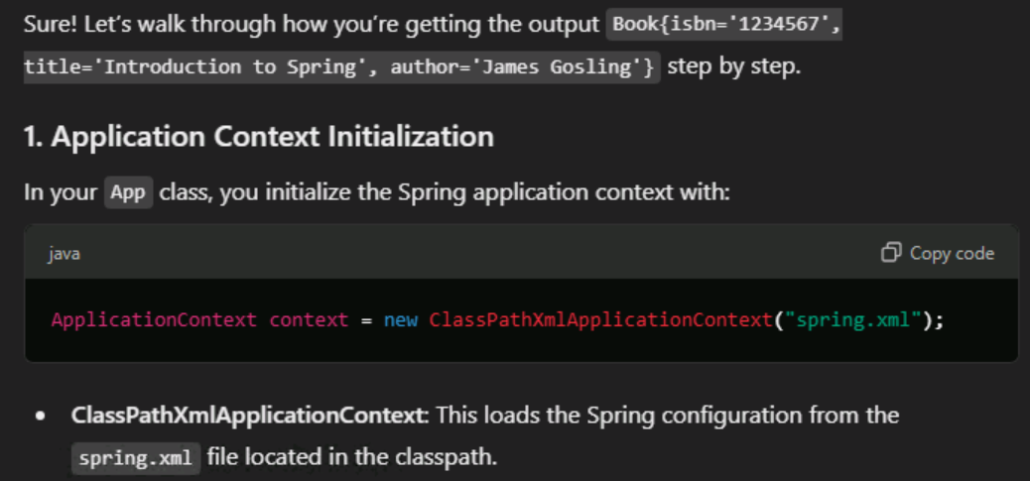

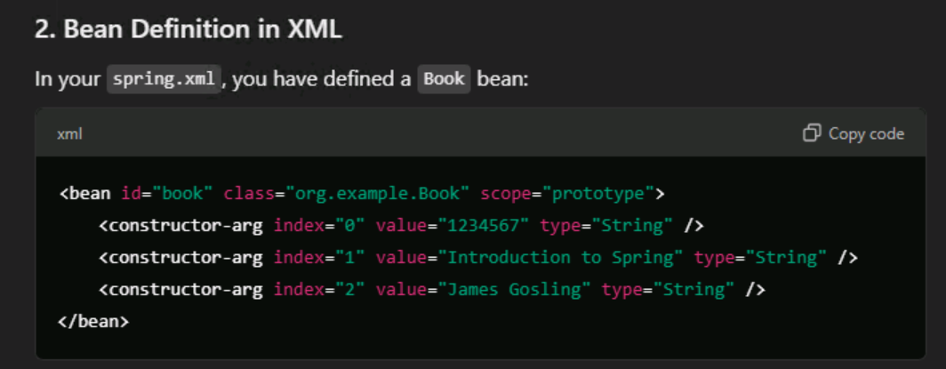

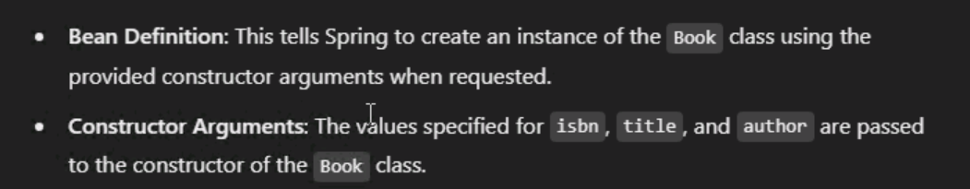

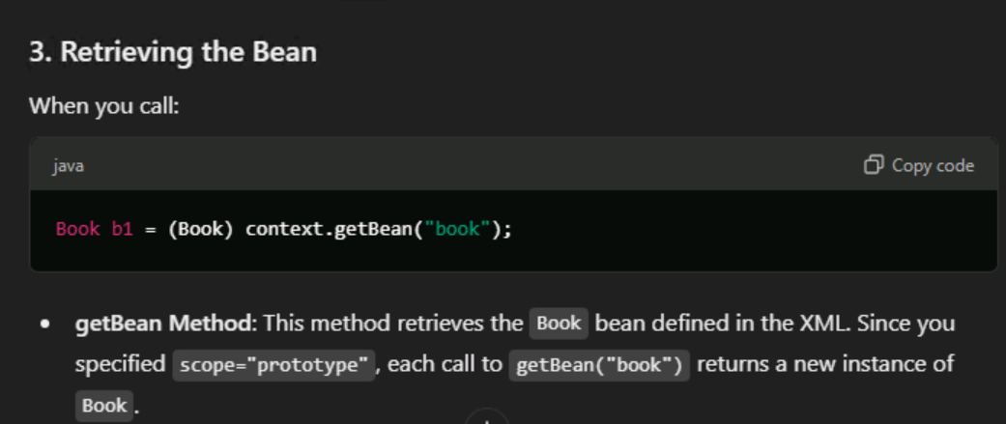

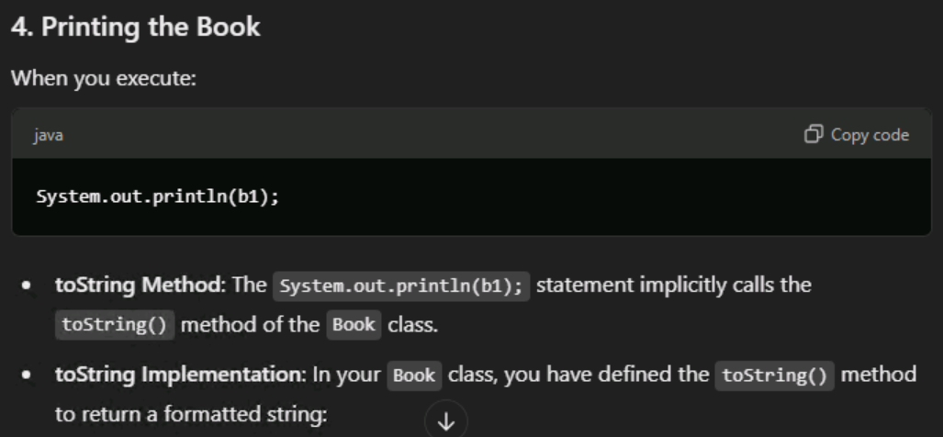

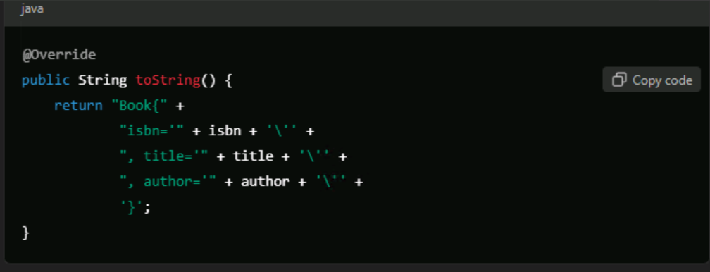

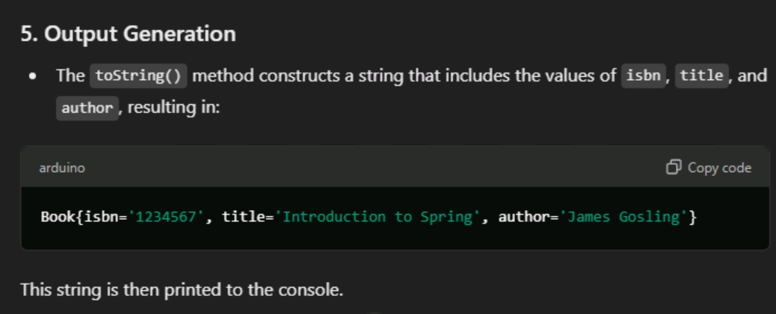

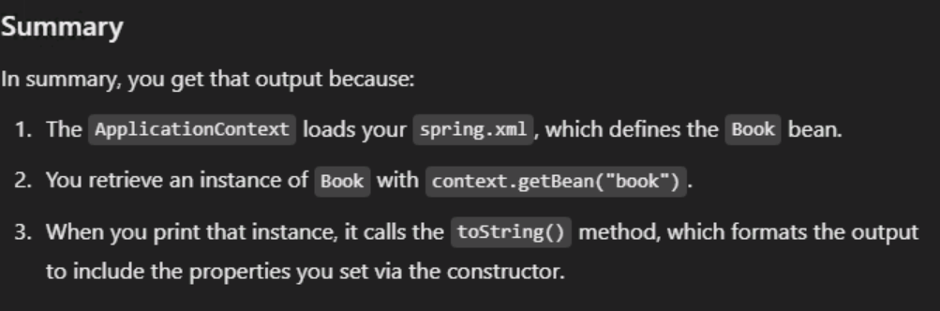

Directly call book from class in app.java code

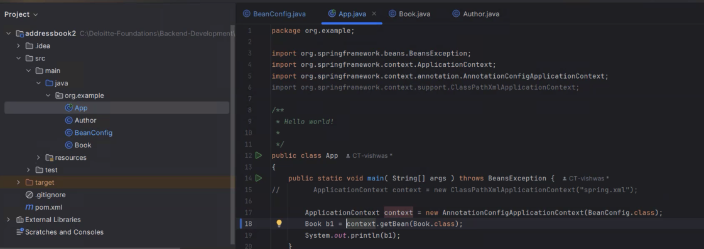

Aspect oriented programming: - means : Breaking the code in to different modules.

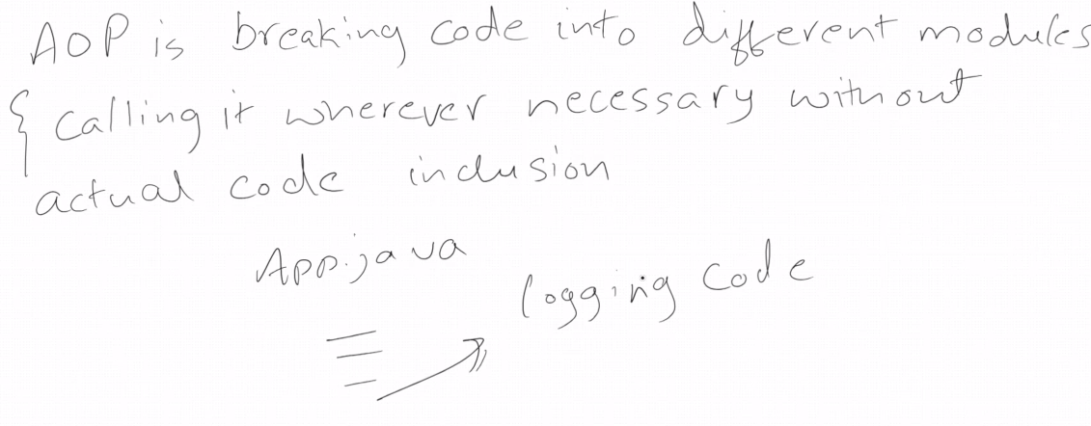

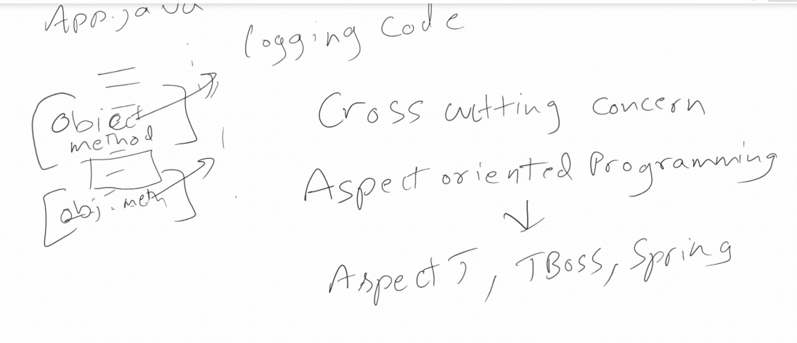

Terminologies : Aspects:

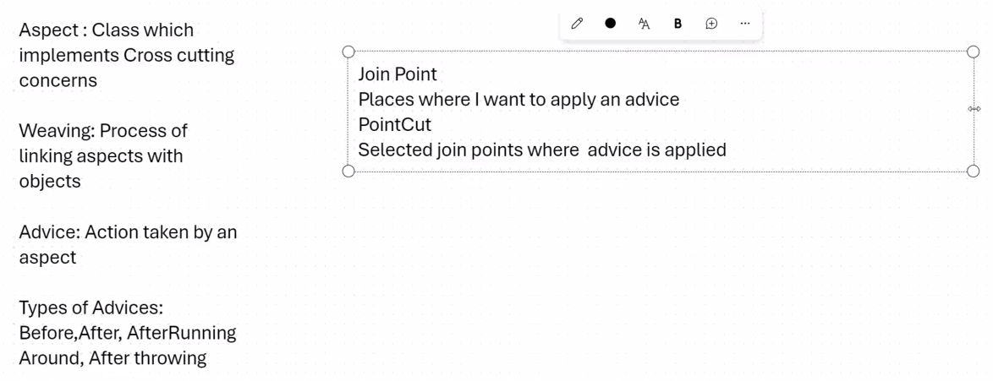

Createa new project maven

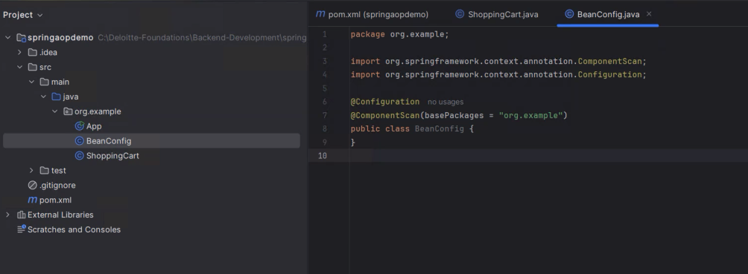

BeanConfig.java

Package org.example

Import org.springframework.context.annotation.ComponentScan;

Import org.springFramework.context.annotation.Confguration;

@Configuration  
@ComponentScan(basePackages = "org.example")  
public class BeanConfig {  
}

ShoppingCart.java

@Componentpublic

class ShoppingCart {

public void checkout(String status) {

System.out.println("Checkout method called...");

}

public int sendAmount(String status) {

System.out.println("sendAmount method called...");

int k = 5;

return k;

} }

Loggingaspect.java

<https://docs.spring.io/spring-framework/docs/3.0.x/spring-framework-reference/html/aop.html>

<https://docs.spring.io/spring-framework/reference/core/aop.html>

<https://start.spring.io/>

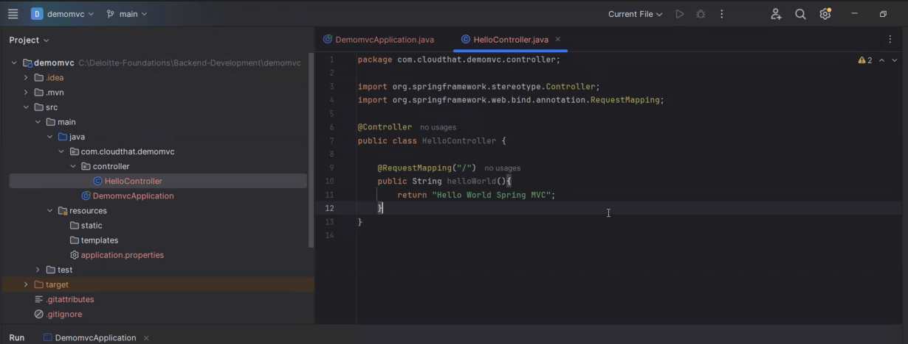

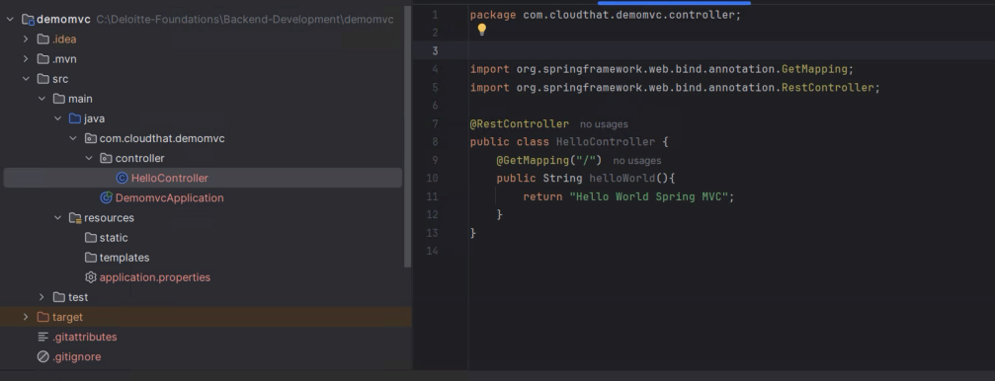

<https://github.com/Deloitte-vishwas/Deloitte-Foundations.git>